Click here for instruction file
MARKET ANALYSIS
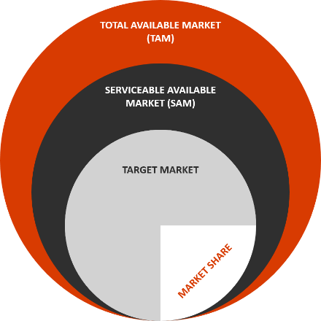
Segmentation
This section is where you will define the main market segmentation as well as the one or two you will be targeting. Begin with the TAM within the industry you plan to compete for. The Serviceable Available Market (SAM), is the subset of the TAM that your company can reasonably serve or market to effectively. Within the last group, is your Target Market. which is a segment defined as a group of people (or other businesses). As your busines expands, you can begin to assess what percentage of your target market you are winning, also defined as your market share.
SWOT
As one example, if your industry is dental medicine, the TAM would be everyone that is in the market for health and hygiene. As a dental office located in the suburbs of Chicago, your SAM might be anyone in a 15-mile radius in need of dental hygiene and attention. Finally, as you develop your unique offers, you might define your focus or target market (segment) as an office focusing on pediatric and family dental health. You can also segment the market by criteria such as quality, price, range of products, operating hours, demographics, geography and others. A few other elements to consider would be to answr questions such as: Is your segment growing, shrinking, or will it plateau over the next few years? What percentage of the market do you think you will be able to reach? What share of the market do you anticipate having within the next 2-3 years? Graphics are best used in a section like this to either show growth (line graph) or percentages of markets or groups (pie chart).

SWOT Analysis:
You can include a SWOT analysis by completing the boxes below to assess your business in the current environment in terms of strengths and weaknesses (internal) and opportunities and threats (external). This is a good exercise to go through on an annual basis. After completing your analysis, provide your thoughts on: how your strengths can help you to maximize opportunities and minimize threats; how your weaknsses can slow your ability to capitalize on the opportunities; and how could your weaknesses expose you to threats?

Competition:
Businesses all compete in one way or another. It may be with specific, direct competitors or it may be with the way customers have been doing things for a long time. They solve their problem in a different way. When identifying the competition, you should identify who else is providing products or services to solve the same problem you are addressing? What are your business’ advantages ovr these competitors? How will your voice be heard over the noise of competitors? Sometimes a business plan includes a matrix of features and compares how each business offers or doesn’t offer those features. This section should reflect how your solution is different and better suited for the target market you have identified than the competition.

Click here for instruction file
MARKET DEVELOPMENT STRATEGY
Developing a Market Analysis for a new medical or dental business provides an entrepreneur a better understanding of the size and specific segments of a market, as well as an evaluation to determine if the targt market will support the business’ growth plans. The Market Analysis is a critical part of any business plan created, whether to inform the business or to communicate to potential investors the siz of the opportunity. A detailed description and sizing of the target market will help the reader understand the market value you are pursuing (the number of potential customers multiplied by the average revene for your product or service).
TAM, method is well known method for Market Analysis.
1: Market Analysis
- Industry Category: Describe the broad industry you will be working in. You want to look up specific SIC codes over the internet for the broad groupings.
- Industry Characteristics: What are the specific characteristics of the industry? Who are the main participants, at a high level? Customers, suppliers, competitors?
- Trends: How is it trending in terms of growth, new participants, new products?
2: SWOT Analysis
This section may also include a (SWOT) Analysis as necessary, to better assess your business’ position against the competition.
- Strengths: What will be your company’s strengths when you launch? How do you see this changing in the future? What are your unique characteristics that make you standout?
- Weaknesses: If you were the competition, what would you say to prospective customers about where your company’s products or services are weak or deficient? What are the most important weaknesses to overcome first?
- Opportunities: With product improvements or new partnerships, where could your business grow? What new segments could you enter in the future? (E.g.: Are you buying an existing practice? Do you have a growing market?)
- Threats: What external factors could put pressure on your business growth or cash flow? Which of these threats can you control? Which ones can’t you control? (E.g.: Are there any new health policies or regulations surfacing that may impact your business? Increased competition?)
3: Methods
Depending on the type of business you are operating, you may or may not need the following methods.
- Total Available Market (TAM): After defining the industry, provide some data on the total number of prospects in the industry or your more narrowly defined market. Is this a particular type of household or geographic location?
- Serviceable Available Market (SAM): From the TAM described above, begin to narrow this down by the actual prospective customers you can reach (service, market to, supply, etc.).
- Market Segments: What are the main segments or groupings that could be defined from the overall industry?
4: Target Market:
Now, after identifying various market.

